ICON
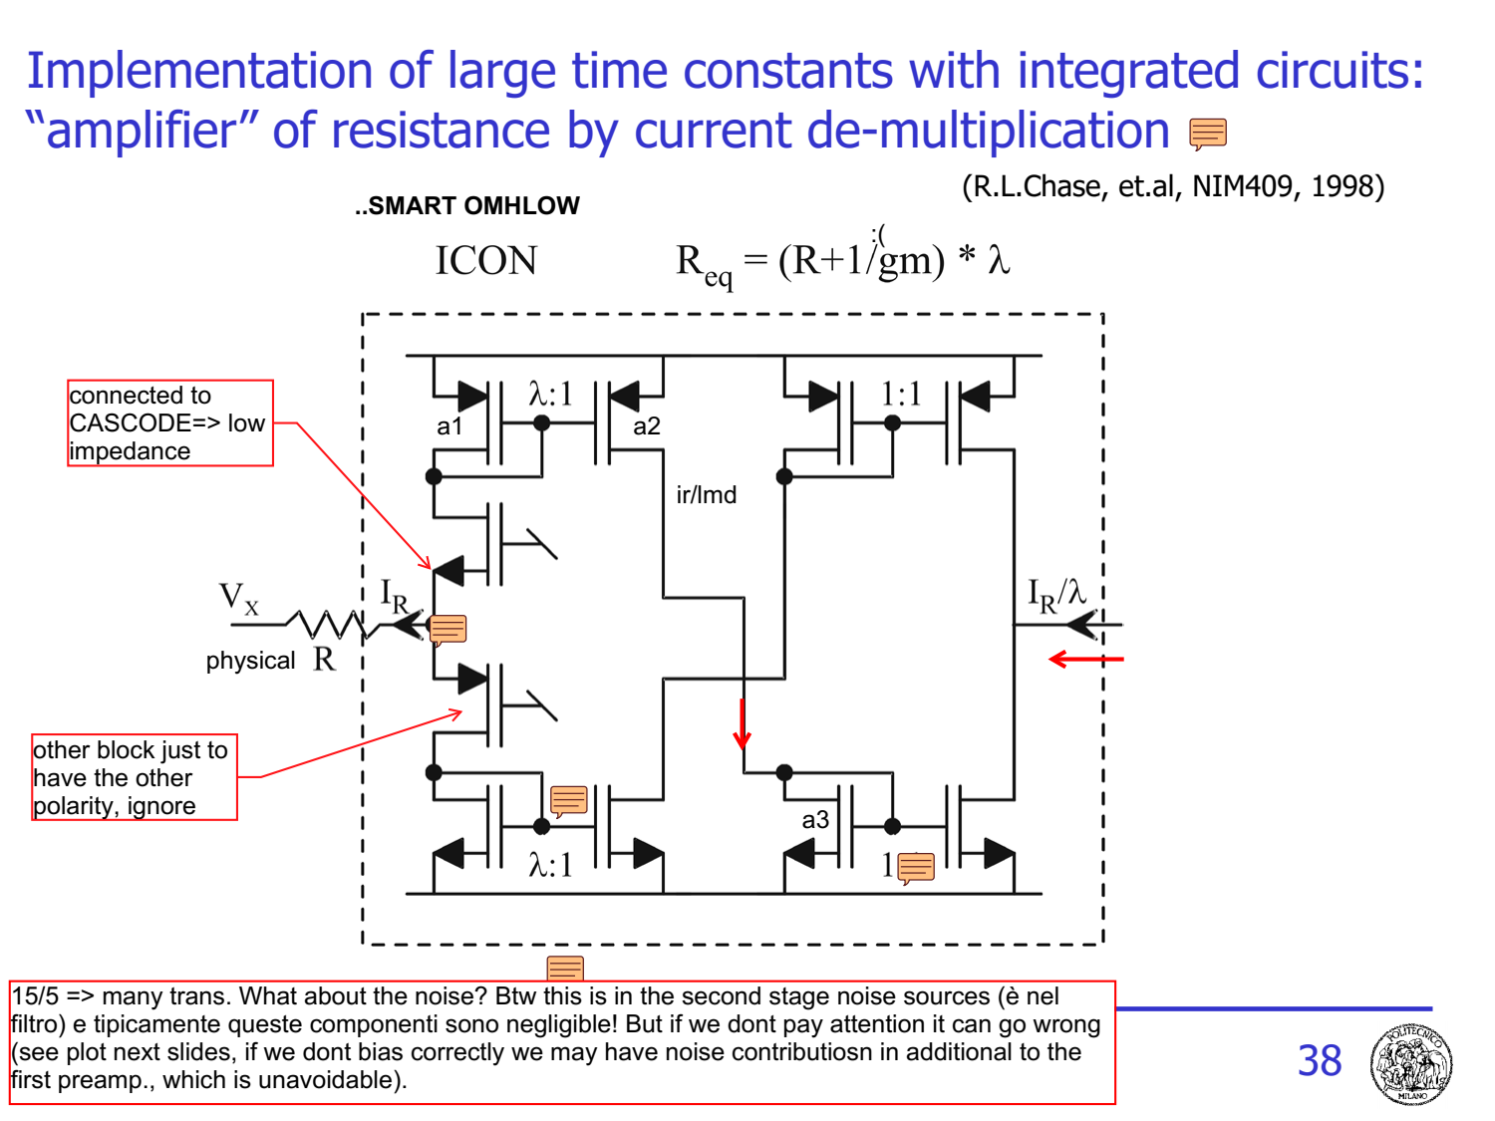
can I implement circuit at slide 27 in CMOS? (stadio filtraggio con i vari poli quadratici) Problem: values of time constant! We have an order of magnitude: ~uSec. Typical pulses are in the order from 100ns-> 1uSec
τ= RC
Assuming C [10pF max] and R = 100kohm
[box] it's critical, large cap etc., we'd like 1pF and 10k usually, because we need to make many of them [box]
NOT POSSIBLE! Can we use mosfet as large resistors? in principle yes. BUT! one thing is the zero/pole cancellation (self compensation of the time constant and variations of VDS), another thing is to implement precise constellation of poles. If we just have R that it's non linear it's really bad (* c’era il problema che in realtà non è una resistenza, e la R varia con Vds, cioè se lo usiamo come resistenza ).
Could we use switched capacitors? PROBLEM: it's limited to low BW. Indeed it's used in bio-signals amplifier, where we have signals in order of khz, which we can cover with nyquist.
- R fisica
- R CMOS tech
  - Cap of 10pF, and R=100kohm
- R as MOSFET in lowthrs.
  - Non linearity with Vds
- R as Swtiching capacitors
  - Low freq
- ICON
=> Here we have MHz/kHz! practically impossible to use switched cap!
ICON IS THE SOLUTION

Working principle
We use a physical Resistor with ok values like 10k, then we use current mirrors and we de-multiply the current. If the impedance is low, Ir = Vx/R
Then the current flow in the cascode (low impedance), enters in the mirror, with mirroring factor lambda (the trasnsistor1 is larger by a factor lambda) output current => lambda times smaller.
This then flows in another mirror (1:1) then it exits.
If I consider the cell a blackbox, given the voltage at the input, which is the current at the output?
it's Vx/R and divided by lambda: Io = $\frac{Vx}{Rλ}$
So the equivalent resistance is R*lambda! I have obtained a virtual resistor lambda times larger than the PHYSICAL resistor on the chip! Thanks to this I can implement whatever resistor. The lambda factor is almost for free, because the space occupation of this is really small!
If I want lambda 10:1 ... we can do a W/L , 1u/1u (a2) and 10u/1u (a1) total area occupation: 11u square. But we can also do: 3/1 (a1) and 1/3 (a2) .. relative ratio.. 9!
total area occupation => um^2!
[ IN CURRENT MIRROR WHAT MATTERS IS THE RATIO OF W/L!]
The last stage is there because it’s necessary to flip again the current! we could send the current already at the output of a2 but that way it's exiting.. implementing a negative resistance! So if we also have this output mirror, we can use it to implement an additional lambda factor of multiplication! I put a λ:1 also here! Thus my equivalent Req $= Rλ^{2}$. We can also make a serpentine with many multiplcations. We cant exceed to much due to current in the end being too low.
So far we have considered only the upper part, the bottom structure is just to make possible double direction of current. The upper works only if the current flows in the direction of the arrow. If the direction is the opposite, the bottom part works (case of entering current)

Valutazione più accurata
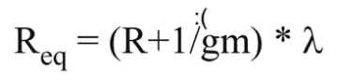
We have considered the node after R to be zero, but actually there’s the $\frac{1}{gm}$ of the transistor. Ir is not just Vx/R, but Vx/(R+1/gm). Thus we have Req as in slide. with R+1/gm multiplied.
And gm depends on the signal . We don’t consider two 1/gm in parallel because we keep them barely biased, and it goes on only one at the time. Ovviamente la variazione di corrente crea una variazione di gm, casino. Però ci saranno easy way to solve the problem.

